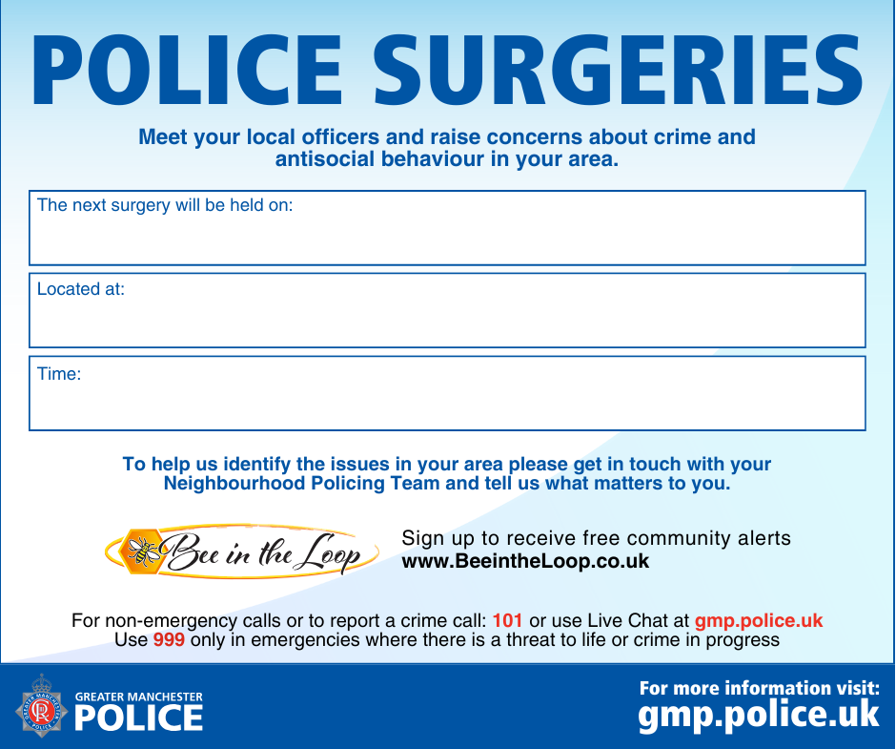
Bardsley community centre, 18A Tensing street, Bardsley,OL8 2TS
1000-1200
23rd of September 2026

