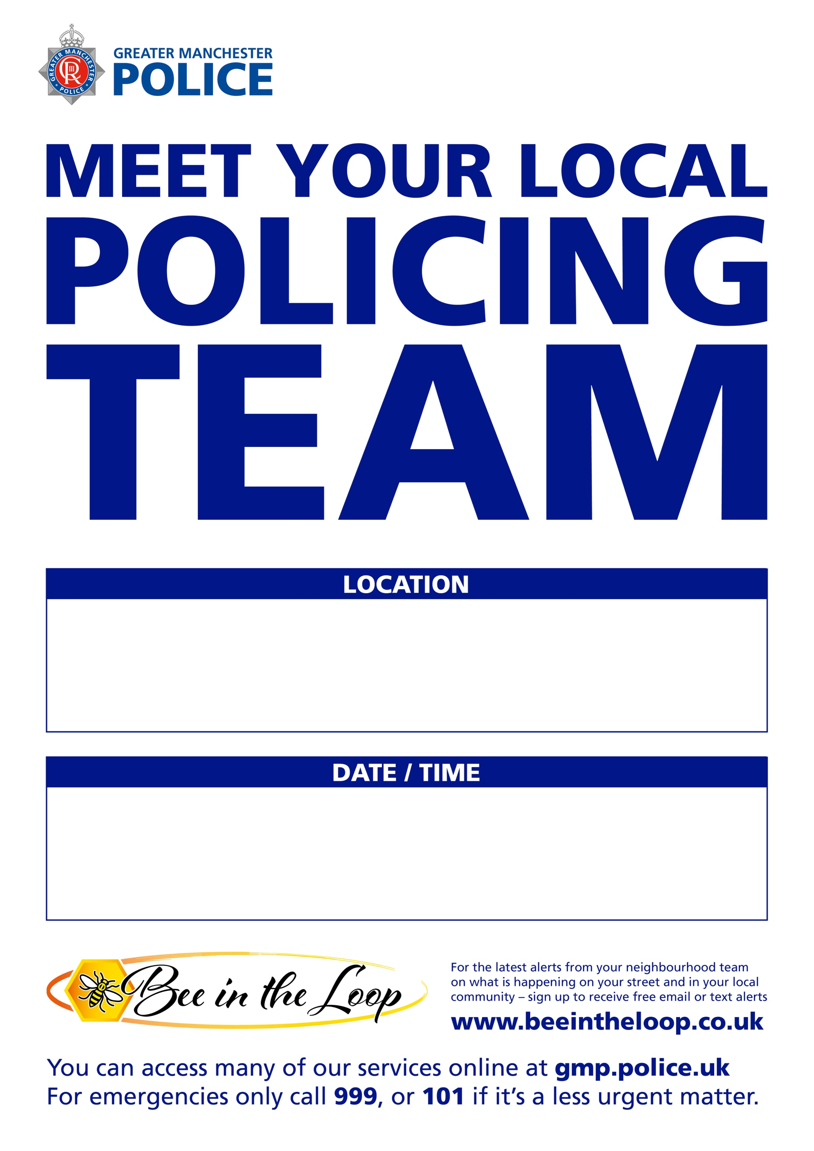
Tuesday 6th October 2026
6.00 pm – 8.00pm
Moss Side Millenium Powerhouse -140 Raby Street, Manchester, M14 4SL

