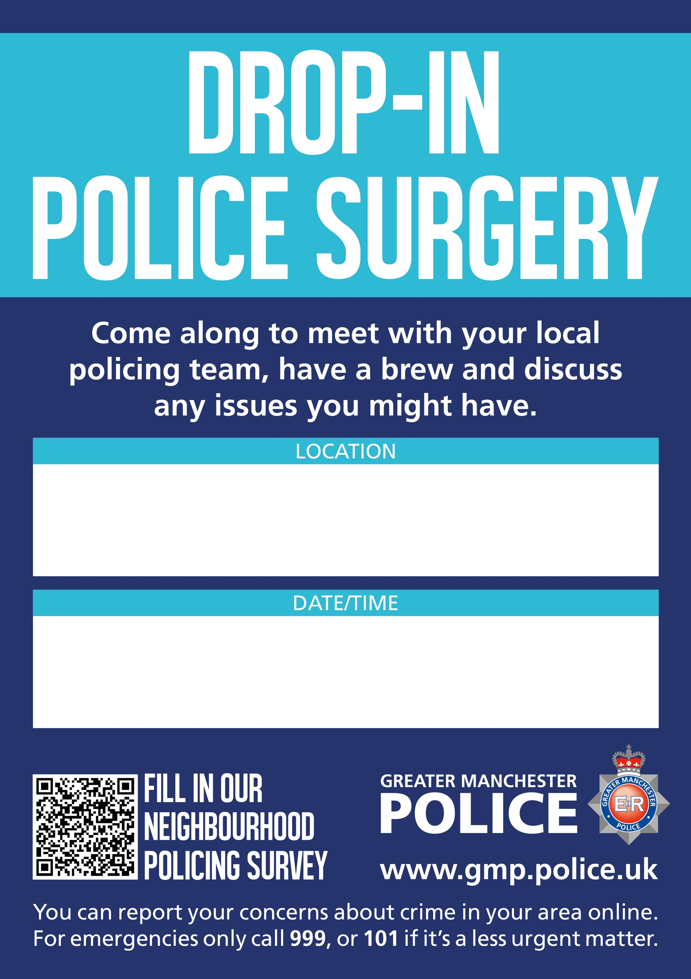
COSTA COFFEE, THE LINKWAY MIDDLEBROOK RETAIL PARK HORWICH BL6 6JA
TUESDAY 19 MAY 2026
2 pm – 4pm

