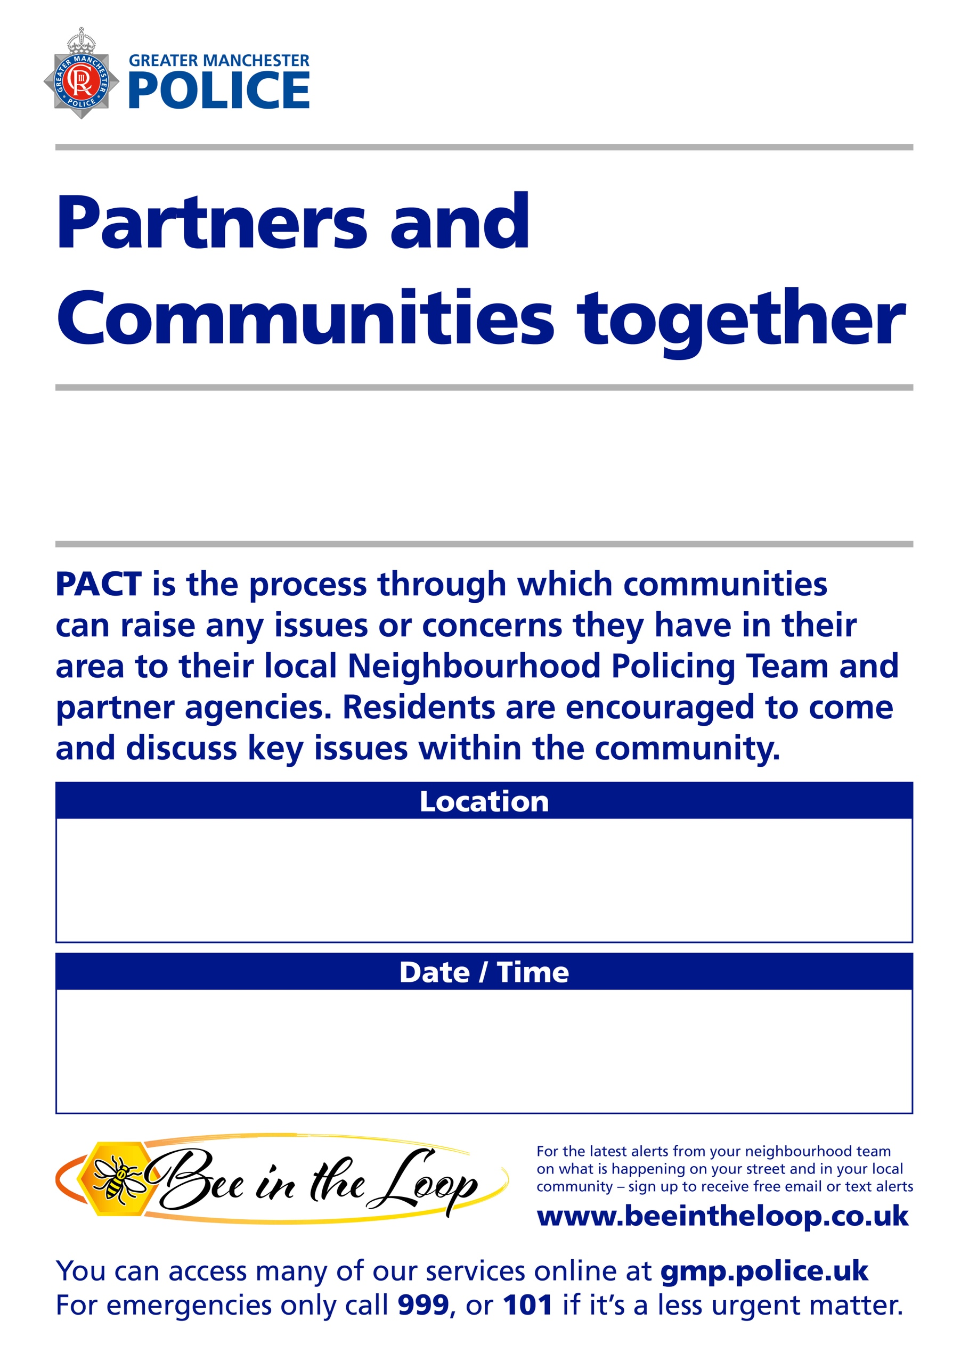
.
Wednesday 22nd July 6pm – 7.30pm
Cheetham and Crumpsall
New Testament Church Of God, Tamerton Drive, Cheetham Hill, M8 0DH

